Histograms and Boxplots Classwork

1. 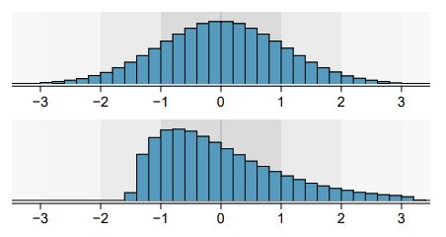Are the following histograms left skew, right skew or symmetric?

Symmetric

Right skew

1. Comparing Boxplots

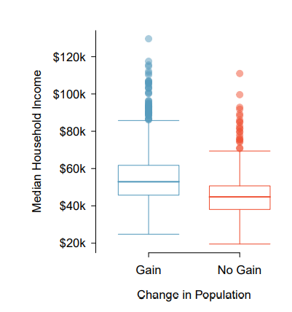

a) Find the median, lower and upper quartiles for both box plots. Use this to find the IQR. Median: gain= 55 no gain=45

LQ: gain=45 no gain=40

UQ: gain=53 no gain=54

b) Which boxplot has a higher IQR? gain

c) Which boxplot has a higher range? gain

d) Are these box plots left skewed, right skewed or symmetric? no gain= symmetric gain=right skew

(Hint: imagine drawing a histogram from the date)